History
In Niort, the protestant reformation ideas began spreading during the Renaissance. As early as 1557, Niort had become a stronghold of protestantism where protestant worship was allowed. During the French Wars of Religion (1562-1598), Niort will be besieged by both Catholics and Protestants in turn. Signed in 1598, the Edict of Nantes will put an end to it and give the freedom of service to some town, among which was Niort.
The first temple in Niort was built at the top of St André Hill in 1591. It was quite a vast building since 6,000 people could attend the service.

Does it still exist ?
The answer is "No", because, on an April Sunday in 1684 two aldermen set a trap : the pastor celebrated the Holy Communion one last time in August 1684 : that was before the King's decree of October 19th 1684 ordering the demolition of the building, and before the Edict of Fontainebleau which revoked the Edict of Nantes.

What about today's temple ?
During the French Revolution, the 10th article of the 1789 Declaration of the Rights of Man and of the Citizen reinstated the freedom of conscience and of worship to the Protestants. On April 15th 1804, the Town Council of Niort granted the old Cordelier church to the Protestant Reformed Church. The Temple was inaugurated on September 1st 1805 in accordance with Napoleon Bonaparte's Concordat agreement.

Architecture
The Temple has retained the shape of the old Cordelier convent church (13th century). It lost one third of its surface area though, at the time of the French Revolution through the destruction of its chapels and part of its steeple and of the back of the original church.
The bay windows on the right part of the entrance as well as the the door arcades, among which some have been blocked, are the original ones.
The patterns decorating the pillars were made between 1679 and 1780. Today's wooden arch was inaugurated in 1926 after the original one fell down in 1922. That one, made of stone, had already been rebuilt in 1679. In the temple, signs of the ancient presence of the Cordeliers (at the turn of the 18th century) can be seen (during guided visits only).

Furniture
Please note the sobriety of the place, a hallmark of Reformed Temples.
- Dating back to the end of the 19th century, you can read biblical verses on the walls.
- A Holy Communion table :
- with a 19th century Bible which is always opened because the Protestant community gather around its reading.
- with a bare cross to signify the Resurrection of Christ.
- with the patchwork logo of the United Protestant Church of France.
- The pulpit in the middle of the back wall is a reminder, too, that reading the Bible is at the core of Protestantism. It was built in 1855 and is registered in the Department inventory, as well as the stalls from 1862.

What about today ?

Niort's Temple is full of life !

Each Sunday, the Reformed community still gather and have been doing so for more than 220 years. They belong to the United Protestant Church of France, created in 2012 by the union of the Reformed Church of France and the Evangelical Lutherian Church of France.

We are, and insist on being, an open welcoming community, witness of the good news of a loving God who makes us live each day. So, on a Sunday morning at 10:30 am, don't hesitate on the threshold : come into the Temple and live a moment of worship, praying and listening to the Bible texts. Every other Sunday (on the 2nd and on the 4th each month) we share the Holy Communion in remembrance of the death and the Resurrection of our Lord Jesus Christ. Each one is invited, as long as they recognize Jesus as our Lord, to form a circle and share the bread and the wine (or grape juice).

A little more than 300 families belong to our community and get our news bulletins. 140 parishioners are involved in Church activities or are members of our association.

We offer religious classes to children and adults, as well as moments when we study and share ideas about the Bible or pray together.

Pastoral acts (christenings, confirmations, weddings or funeral services) also take place in this temple every now and then. We also support and help persons who encounter loneliness or hardship.

Feel free to contact us.
Welcome to the Niort Temple !
United Protestant Church of the Niort District

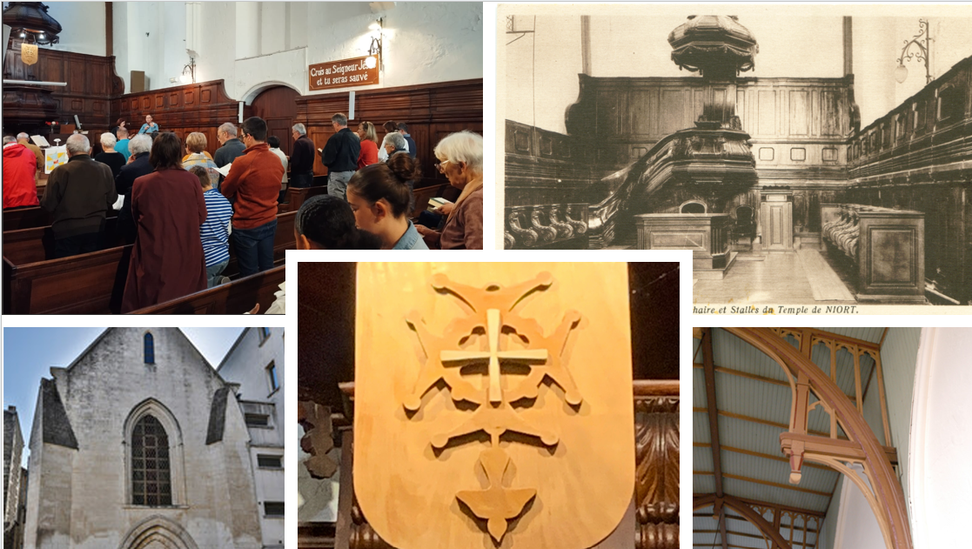

Eglise Protestante Unie du Pays Niortais
Téléphone : 07 81 79 52 41
Church Mission Head : Mélanie Pérès
Site : https://pays-niortais.epudf.org/


